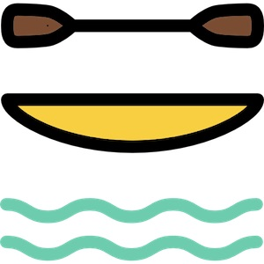

Deowater Rafting Website plan

Color Palette
- Primary Color: #264969 (Steel Blue)
- Secondary Color: #505033 (Dark Olive Green)
- Accent1 Color: #CFCFB4 (Beige)
- Accent2 Color: #B4CDE4 (Light Blue)

Typography
- Heading Font: Montserrat
- Body Text Font: Merriweather

Coolors Palette URL
https://coolors.co/505033-264969-cfcfb4-b4cde4

I

